**Network devices types**

### ****Hub****

* A hub is one of the simplest networking devices that connects several computers
* a hub is a hardware device that allows multiple devices or connections to connect to a computer.

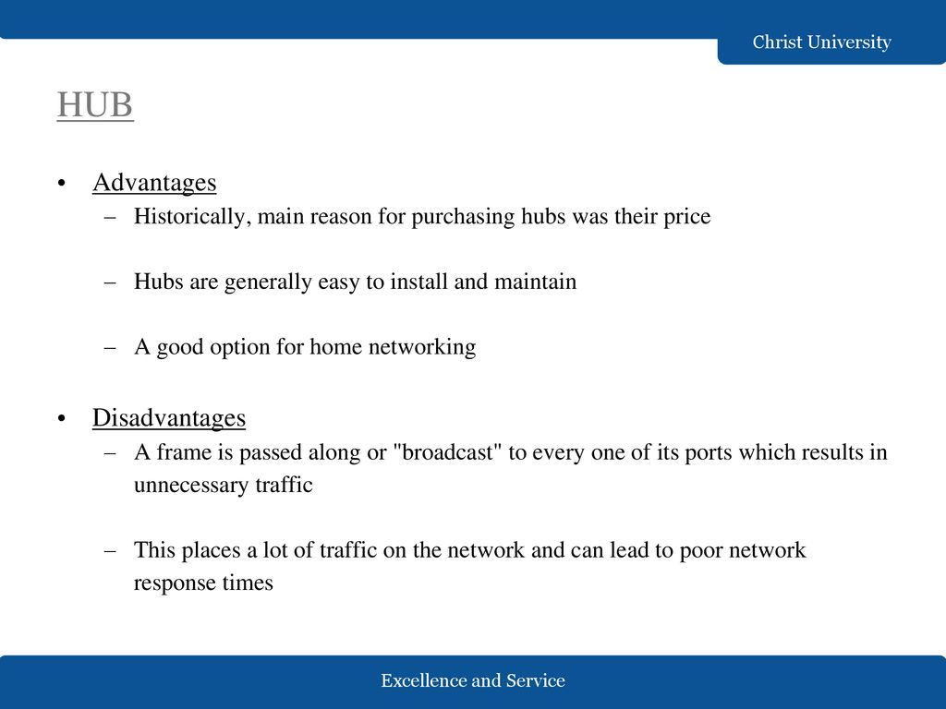

### Types of Hub

There are three types of the hub that are given below:

1. Passive Hub
2. Active Hub
3. Intelligent Hub

**Passive Hub:**

* This connector is connected to all [local area network (LAN)](https://www.javatpoint.com/wireless-lan-introduction) devices.
* The passive hubs are the connection point for wires make the physical network

**Active Hub:**

* As compared to a passive hub, it includes some additional features.
* It is able to monitor the data sent to the connected devices.

**Intelligent Hub:**

* It is a little smarter than passive and active hubs
* Furthermore, with any physical device, if any problem is detected, it is able to detect this problem easily

**Modem:**

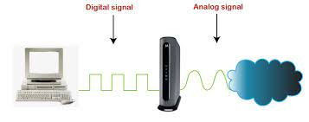

A modem is a device that connects your computer or router to the internet via a telephone or cable line. It converts the digital signals produced by your computer into analog signals that can be transmitted over the telephone or cable lines.

**Modem types:**

**Dial-up modems:** These are the oldest and slowest type of modems, which use a phone line to connect to the internet.

**DSL modems:** These modems use digital subscriber line technology to connect to the internet over a phone line, but they are much faster than dial-up modems.

**Cable modems:** These modems use a cable connection to connect to the internet, and they are typically faster than DSL modems.

**Satellite modems:** These modems use a satellite connection to connect to the internet, which makes them a good option for remote or rural areas where other types of internet connections may not be available.

**Cellular modems:** These modems use a cellular network to connect to the internet, and they are often used for mobile devices like smartphones and tablets.

**Fire wall:**

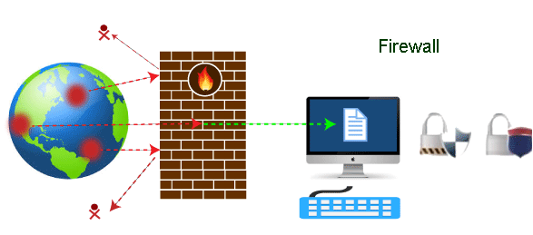

A Firewall is a network security device that monitors and filters incoming and outgoing network traffic based on an organization's previously established security policies.

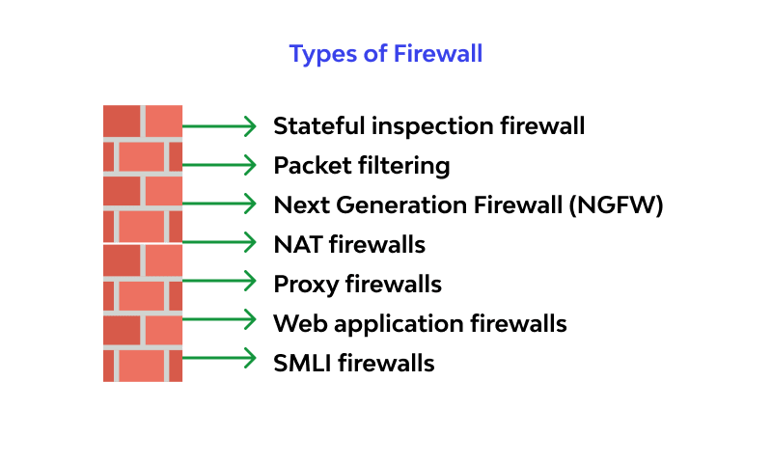

**Firewall advantages and disadvantages**

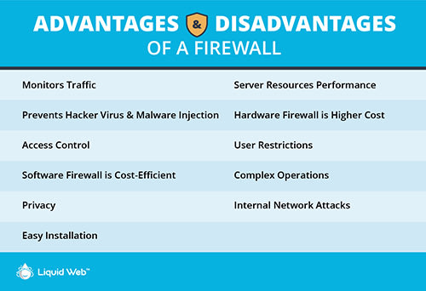

Setting IP Address

**Subnet mask**

**Classes of IP address**

**Subnet mask**

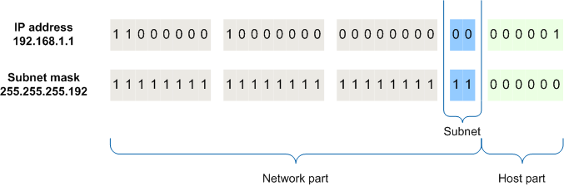A subnet mask is used to divide an IP address into two parts. One part identifies the host (computer), the other part identifies the network to which it belongs.

**Classes of IP address**

These classes are class A, class B, and class C.

